|  |
| --- |
| COLLEGE OF ENGINEERING, PUNE |
| NSAF AND SNS PROJECT |
|  |
|  |
|  |
|  |

|  |
| --- |
|  |

**VAISHNAVI AGRAWAL 111707071**

**SHARIVA DHEKANE 111713014**

**NEHA TUNIYA 111713039**

**Topic:** Rotating solar panels depending on the intensity of incident light.

**Objective:** Efficient energy generation

The overall data flow and signal processing process is shown in the block diagram below:

Light Detection

Circuit

Read the

intensity of

light

using

MSP430F5529

Process the

light

intensity to get

the direction

of light

Read the angle

values to rotate

the solar panel

accordingly

1. **Detecting source of light:**

Using a Light Dependent Resistor (LDR) to detect the intensity of incident light. It is also known as a photoresistor.

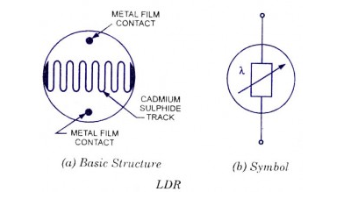 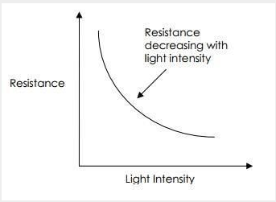

When the light level decreases, the resistance of the LDR increases. The photo resistivity may vary widely depending on ambient temperature. The main component for the construction of LDR is cadmium sulphide (CdS), which is used as the photoconductor and contains no or very few electrons when not illuminated. In the absence of light it is designed to have a high resistance in the range of mega ohms. As soon as light falls on the sensor, the electrons are liberated and the conductivity of the material increases. When the light intensity exceeds a certain frequency, the photons absorbed by the semiconductor give band electrons the energy required to jump into the conduction band. This causes the free electrons or holes to conduct electricity and thus dropping the resistance dramatically (< 1 Kilo ohm).

The equation to show the relation between resistance and illumination can be written as

R = A.E^a

where E–Illumination(lux), R–Resistance(Ohms), A, a – constants

The value of ‘a’ depends on the CdS used and on the manufacturing process. Values usually range between 0.7 and 0.9.

1. **Driving the solar panels**

A servo motor is an electrical device which can push or rotate an object with great precision. If you want to rotate and object at some specific angles or distance, then you use servo motor. It is just made up of simple motor which run through servo mechanism. It consists of three parts:

1. Controlled device 2. Output sensor 3. Feedback system

It is a closed loop system where it uses positive feedback system to control motion and final position of the shaft. Here the device is controlled by a feedback signal generated by comparing output signal and reference input signal. Here reference input signal is compared to reference output signal and the third signal is produces by feedback system. And this third signal acts as input signal to control device. This signal is present as long as feedback signal is generated or there is difference between reference input signal and reference output signal. So the main task of servomechanism is to maintain output of a system at desired value at presence of noises. Servo motor works on PWM (Pulse width modulation) principle means its angle of rotation is controlled by the duration of applied pulse to its Control PIN. Basically servo motor is made up of DC motor which is controlled by a variable resistor (potentiometer) and some gears. High speed force of DC motor is converted into torque by Gears. We know that WORK= FORCE X DISTANCE, in DC motor Force is less and distance (speed) is high and in Servo, force is High and distance is less. Potentiometer is connected to the output shaft of the Servo, to calculate the angle and stop the DC motor on required angle.

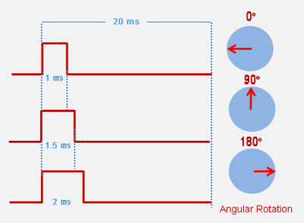 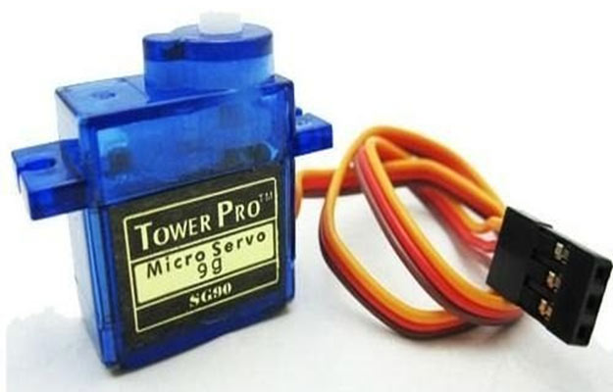

1. **The Code**

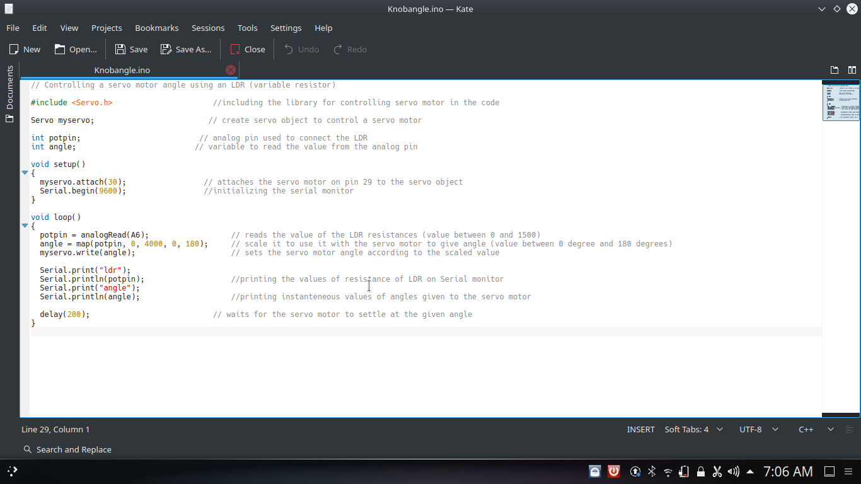

Here, we have to first use software called Energia which is open source software. Energia does not require us to produce a register level code but a code in English language using the energia syntax works well. In the code, first we need to include a library called <servo.h> to tell the software that we are going to be using this library. Then we declare an object called myservo. It is basically a variable that we are going to use to access the different functions of the servo.h library. Then declaring the variables required for coding the other parts, we move on to the setup. Serial monitor helps us to get the instantaneous values of the particular variables. Now we initialize the serial monitor and attach the myservo object to the pin number to which the pwm pin of the servo motor is attached. In the void main() part of the code, we read the instantaneous values of the LDR using the analogRead function. We use the map () function of the servo library to map the values of this LDR to give the servo motor angles at which it should rotate. This angle is given to the servo motor using the myservo.write command. Then using Serial.print, we print the instantaneous values of the LDR and the angles of the servo motor on the serial monitor. The map function works in the following way: map(value, fromLow, fromHigh, toLow, toHigh) The whole function is actually:

long map(long x, long in_min, long in_max, long out_min, long out_max){ return (x - in_min) * (out_max - out_min) / (in_max - in_min) + out_min; }

1. **Results**

The values of angle given to the motor changes according to the intensity of light incident on Light Dependent Resistor. The motor reads it based on the PWM given to it. According to the intensity of light incident on the light sensor, the duty cycle of the PWM varies and hence the angle of the motor changes. Stepper motor can also be used instead of the servo motor to rotate the solar panels.

1. **Conclusion**

This project shows us how the rotating solar panels can generate energy effectively. The motor and the microcontroller used here is a low power device but for practical applications, high power devices are to be used. The sensor used in the project is a simple LDR but for practical application, a high precision sensor that detects merely sunlight should be developed.